Python Assignment Exception Handling

248518 Gaurav B Raskar

Q.1.

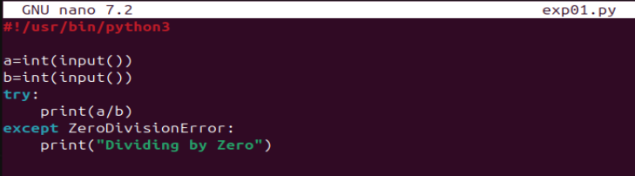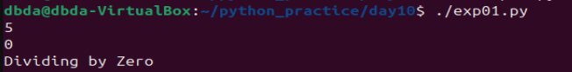

Q.2.

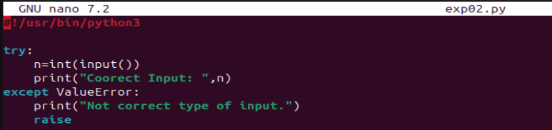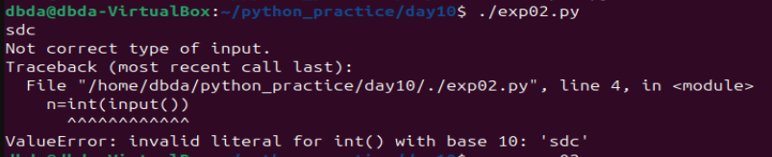

Q.3.

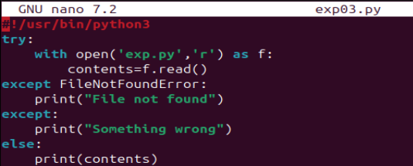

Q.4.

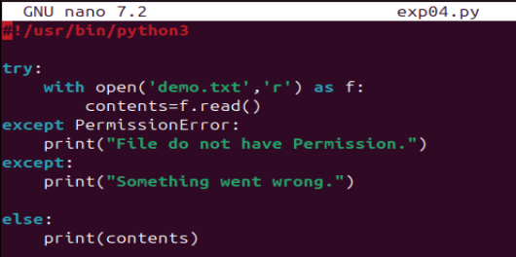

Q.5.

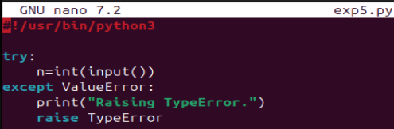

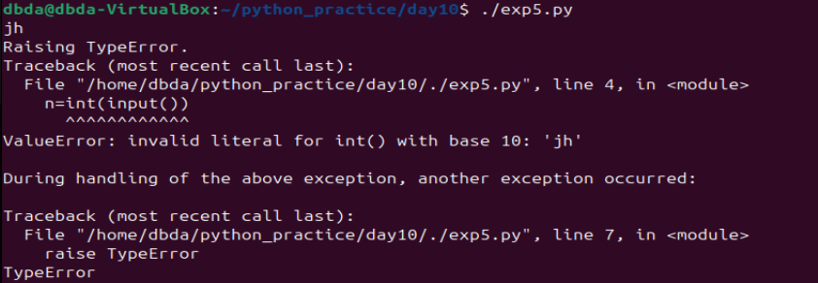

Q.6.

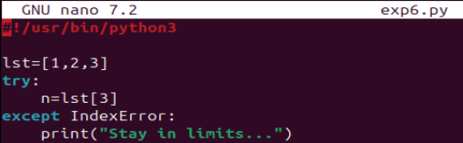

Q.7.

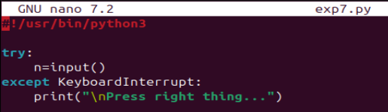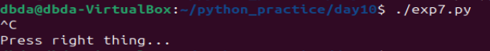

Q.8.

